Blackhall St. Columba’s Church

FIRE EVACUATION PROCEDURES AND ARRANGEMENTS

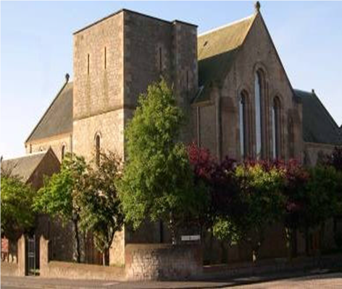

Issued by: Blackhall St Columba’s Church
Date Issued: September 2023

Page | CONTENTS
2 | Introduction
2 | Emergency Telephone Numbers
2 | Location of Main Services for Isolation
3 | Fire Action Notice
4 | Procedures for Contractors and Lets
4 | Evacuation of Persons Requiring Additional Assistance
4 | Fire Evacuation Drills
5 | Nominated Personnel
6 | Fire Escape Plan
7 | General Fire Safety Guidance for Building Users
8 | Terms and Condition of Let
9 | End
INTRODUCTION

An outbreak of fire anywhere within the premises has the potential to cause significant risk to life and property. The emergency procedures provided within this document sets out the actions that occupants should take in the event of a fire emergency. The purpose of the procedures is to ensure that people in the premises know what key actions are required to be carried out in the event of fire and know what to do to safely evacuate the premises. All occupants using or having control of the building to any extent should follow this procedural document as a minimum.

Suitable arrangements, by way of nominating key persons to assist during emergencies, will be required to carry out all the key duties listed within this document. The number of persons nominated to assist should relate to the size of the event and the expected number of persons using the building.

KEY EMERGENCY TELEPHONE NUMBERS

Emergency Services: | Congregational Health and Safety Administrator:
999 | Lindsay S. Duguid 0131 569 0846 or 07831 147213
Gas/Oil Fixed Heating Services: where applicable | Fire Alarm Company: where applicable
National Gas - 0800111999 | Chubb - 0800 321666
Electrical Services: | Add as necessary:
Scottish Power - 105 or 08000929290

Water Services: | Add as necessary:
Scottish Water - 08000778778

LOCATION OF MAIN SERVICES FOR ISOLATION

Location of Mains Gas Isolation Valve:
In the large green box immediately outside the entrance to the Church Halls.

Location of Mains Electrical Services:
In cupboard, immediately to the left inside the main entrance to the Church Halls.

Location of Mains Water Isolation Valve:
In Toilet at Columba Road entrance to Church.

FIRE ACTION NOTICE

On Discovering Fire

- Raise the alert by immediately giving the shouted warning of fire and/or by pressing the nearest red break glass call point.

- Leave the building using the nearest and safest fire exit.

- Report to Fire Assembly Point: North side of Columba Road.

- Verify a fire to be real or false before calling emergency services by dialling 999.

- Undertake a roll call at the assembly point to account for any missing persons.

On Hearing the Shouted Warning of Fire or Audible Alarm Signal

1. Immediately leave the building using the nearest and safest emergency exit.

2. Report to the fire assembly point.

3. Verify a fire to be real or false before emergency services have been summoned by dialling 999.

4. Undertake a roll call for missing persons as necessary.

IMPORTANT

- Treat all alerts as genuine and react swiftly to leave the building, and assisting any persons in your care as necessary.

- Close doors to the rooms or area of fire if safe to do so (this can restrict the spread of flames and smoke).

- Where summoned, the Fire and Rescue Services shall be met at the main entrance
of the building and given information that the building is clear of occupants and the
approximate cause and location of the fire.

- Do not re- enter the building until it confirmed safe to do so by key personnel or the the Fire and Rescue Services.

PROCEDURES FOR CONTRACTORS AND LET’S

Contractors will be briefed on the key fire action procedures and specific fire safety information for the building on arrival. Contractors will be responsible for their own evacuation when undertaking works in areas that are not normally occupied, such as basements or attics, unless specifically accompanied by a member of the church whilst conducting their activities.
Contractors will be responsible for all persons in their care during an emergency, and for summoning and meeting the Fire and Rescue Services, where they have full control of the building out with normal opening hours.

Let’s group leaders/organisers should be identified and be provided with the key fire action procedures and specific fire safety information for the building on arrival, or in advance of the booking. Identified Let group leaders have the responsibility of accounting for all persons in their care during emergencies, to communicate with other Let’s using the building, and to summon and meet the Fire and Rescue Services where they have control of the building to any extent, unless specifically accompanied by a member of the church whilst conducting their activities.

EVACUATION OF PERSONS REQUIRING ADDITIONAL ASSISTANCE

Persons to the building that require the use of wheelchairs or that have significant visual, hearing or cognitive impairments shall be provided with a level of assistance to evacuate as part of the fire warden arrangements for the building. Where key personnel are not in attendance, such as Let’s hire, arrangements to evacuate persons with significant disabilities must be addressed by the activity group leader, either prior to any event or undertaken dynamically during an emergency situation.

Young persons and children are also considered to be at higher risk and should be suitably assisted during fire emergencies. The level of risk should be evaluated prior to any events or hired use of the premises, to ensure suitable numbers of required persons to assist are available.

FIRE EVACUATION DRILLS

Fire evacuation drills will be conducted at a minimum frequency of 1 per 12-month period. Drills may be arranged to take place at any time during opening hours and will be carried out as realistically as possible with the aim to test the emergency procedures and arrangements in place. It is strongly advised that Let group leaders conduct their own practice drills to test alternative procedures and arrangements in place for ensuring the safety of they’re group.

NOMINATED PERSONNEL

The following personnel will be nominated to carry out fire safety duties for emergency situations during church organised events and regular church services.

FIRE EVACUATION COORDINATORS:

Minister, Beadle and Welcome Team at church services and Event Leaders at all other times.

Emergency Duties:

Confirming the fire to real

Confirming the 999 call has been made

Confirming the approximate location of the fire (by viewing the fire alarm panel)

Confirming the building is clear of all occupants

Meeting the Fire and Rescue Services on arrival

Giving the signal to re-enter the building

Note: The Fire Evacuation Coordinator will be located at the main entrance to the building during emergency evacuations.
FIRE WARDENS (the number of which is dependent on the size of any given event):

Minister, Beadle and Welcome Team at church services and Event Leaders at all other times.

Emergency Duties:
- Confirming the fire to be real
- Dialling 999
- Ensuring occupants are aware of the alarm and are evacuating the building
- Sweep/search of pre-designated areas of the building on way to exit
- Tackling fire if safe to do so
- Reporting all information to the Fire Evacuation Coordinator

All duties to be carried out where safe to do so.

Non-Emergency Duties – In house fire equipment test and inspection regime
Responsible person:

Property Convenor and H & S Administrator

- Daily visual check of escape routes and fire exit doors for functionality.
- Weekly fire alarm test.
- Weekly visual inspection of fire extinguishers for damage/used or missing equipment.
- Monthly Emergency Lighting Test to check functionality.
- Monthy housekeeping inspection of high fire risk rooms i.e. Boiler room, mains electrical cupboard, switchgear room

FIRE ESCAPE PLAN

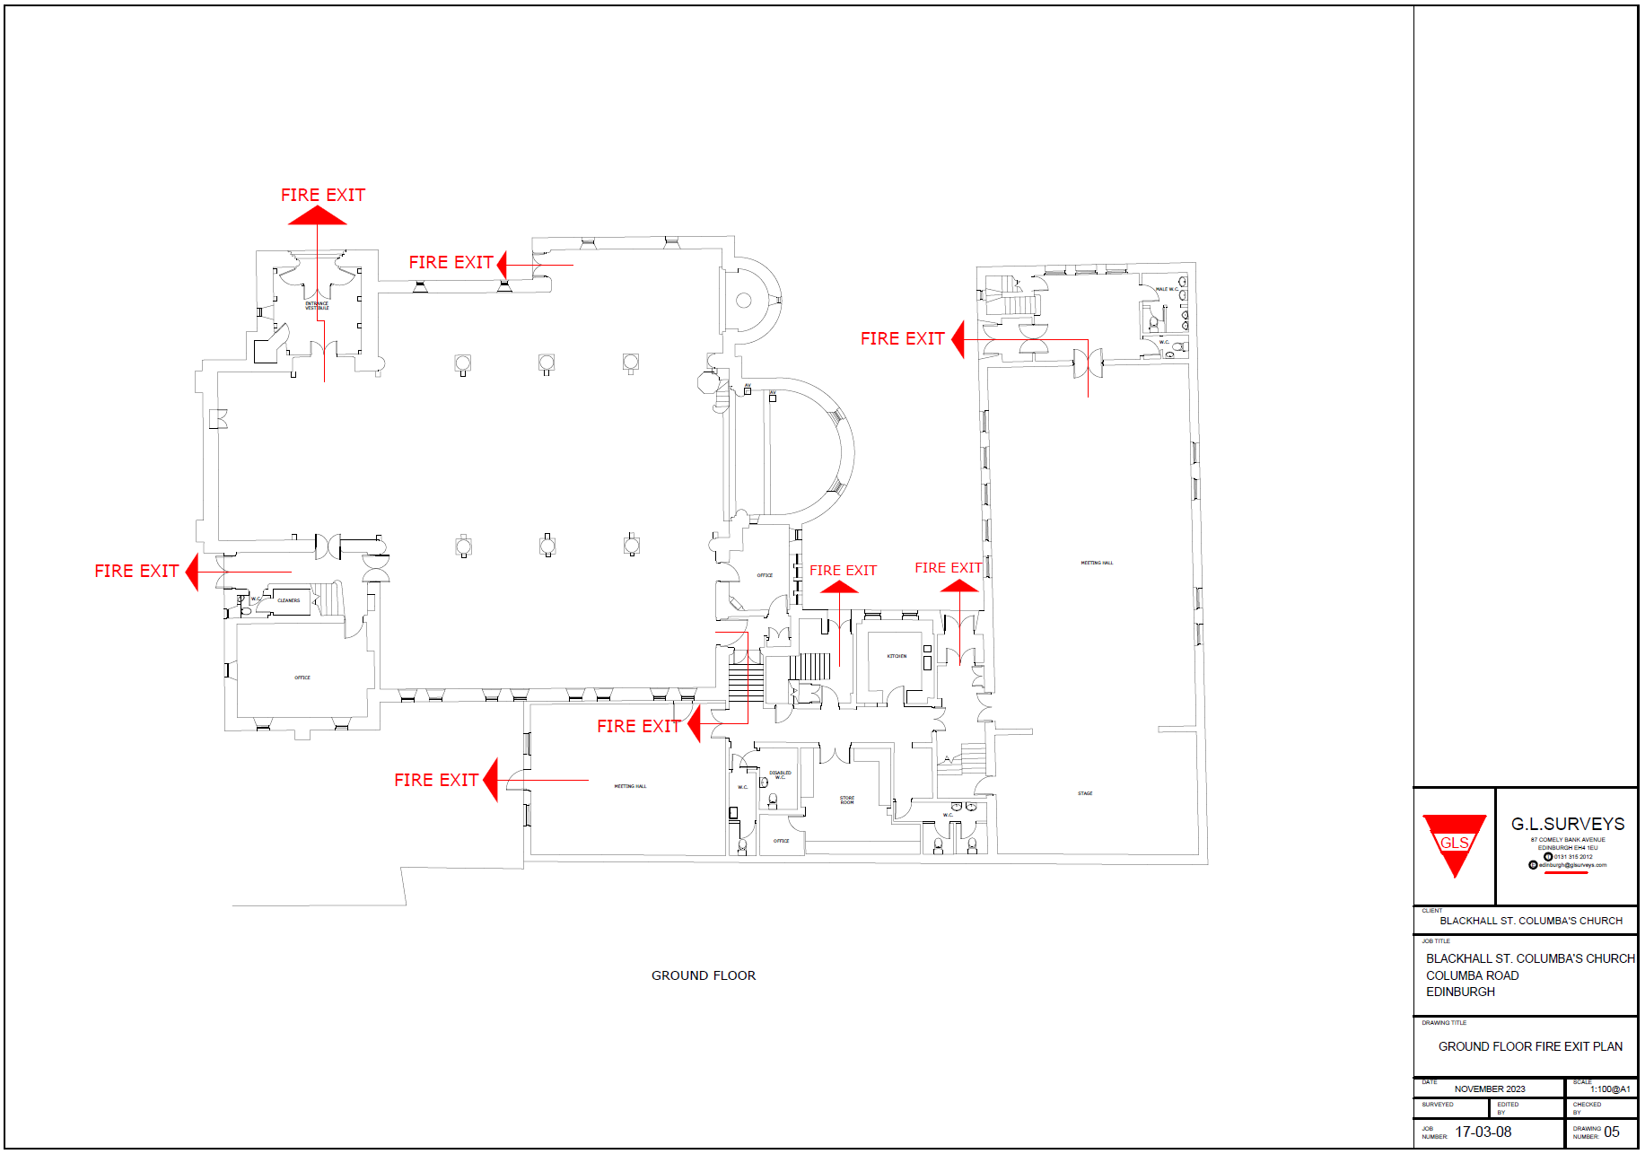
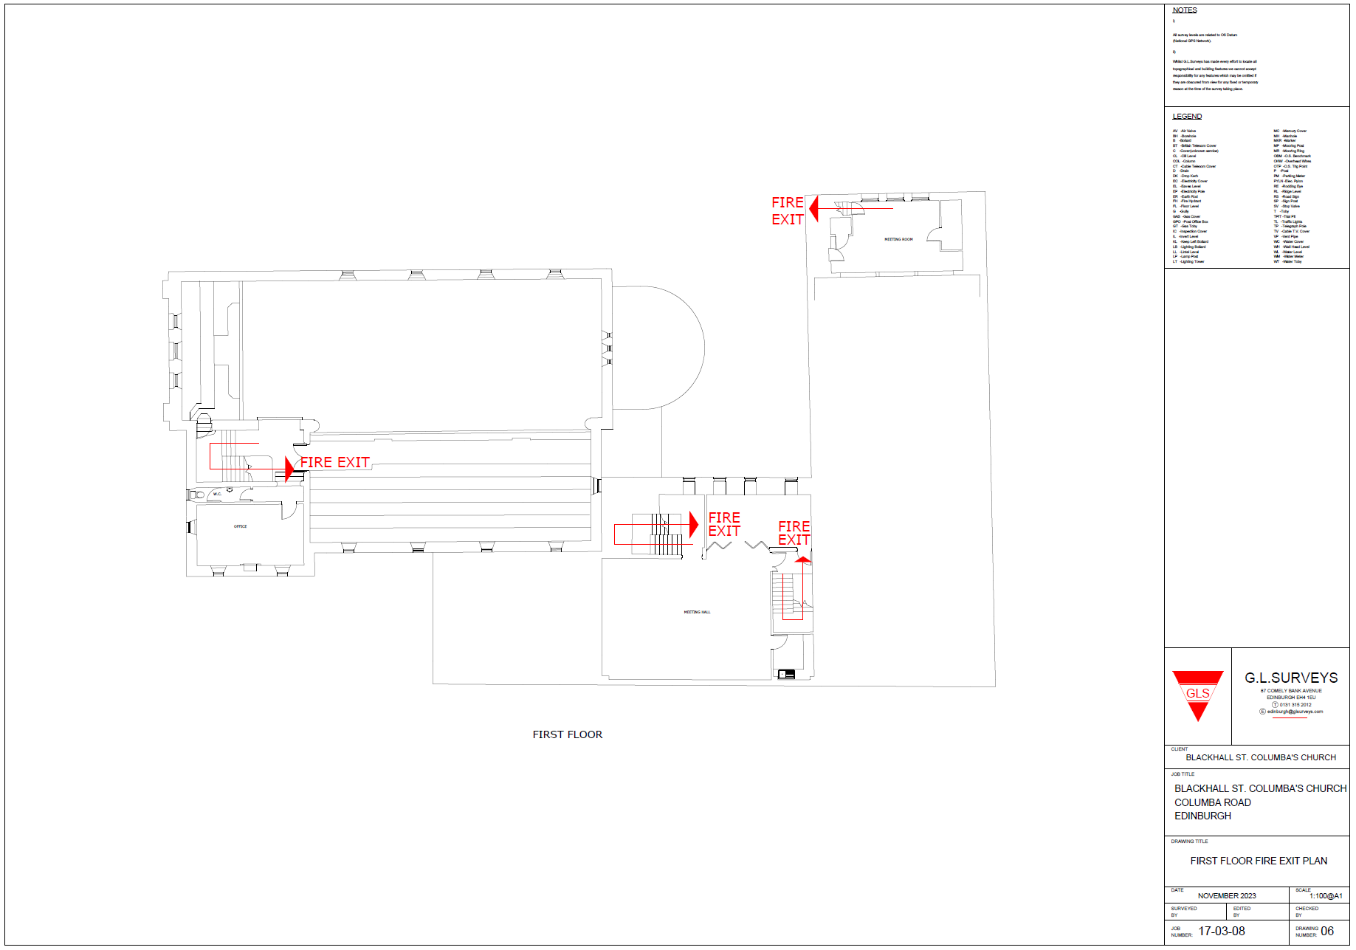
GENERAL FIRE SAFETY GUIDANCE FOR ALL USERS OF THE BUILDING
FIRE ASSEMBLY POINT B

Appropriate care should be taken by all persons to reduce the likelihood of a fire starting within the building by act or omission, including malicious fire setting. As a guide the appropriate practices to follow are:

Housekeeping

- Avoid storing combustible materials in boiler rooms and mains electrical rooms
- Keep escape routes and escape stairwells clear of combustible items, significant ignition sources and items that could cause obstruction
- Ensure waste materials and other rubbish is removed regularly

Electrical

- Ensuring plug sockets and extension leads are not being overloaded (13 Amps in total load for each plug socket and/or extension lead)
- Ensuring trailing cables are free from damage or distortion from furniture items or other fixture within rooms
- Ensure heat generating equipment has sufficient ventilation and that combustible items are not in direct contact
- Switching off non-essential equipment where it is not in use for long periods i.e. Overnights, weekends and holiday periods

Smoking

- Smoking is not permitted within the building, persons wishing to smoke must do so externally to the grounds

Cooking

- All cooking activities should be supervised
- Cooking appliances should be switched off and isolated after use, including shut downs during emergencies

Hot Works

- Heat generating activities such as welding, soldering and grinding should be strictly controlled and subject to risk assessment prior to starting the task

Storage & Use of Dangerous Substances

- Substances labelled explosive, oxidising, extremely flammable, highly flammable or flammable or any dust which can form an explosive mixture with air or an explosive atmosphere should be risk assessed, and appropriately used/stored

TERMS AND CONDITIONS OF LET
FIRE ASSEMBLY POINT B

For the purposes of these conditions the ‘Hirer’ will mean an individual hirer or, where the hirer is an organisation, the authorised representative.

Equipment: Any electrical equipment brought into the building must be appropriately PAT tested. Appropriate risk assessments and supervision must be considered and applied.

Smoking is not permitted in any part of the building. During an event, it is the organiser who is responsible for ensuring those attending do not smoke.

Sub Letting: the hall should not be sub-let without prior permission of the Church.

Candles/Smoke Machines: Please note we do not allow the use of candles or smoke machines. Our fire alarm systems are very sensitive and naked flames are strictly prohibited.

Hirer Responsibility

Health and Safety: Organisers of the let should acquaint themselves with the position of fire points, emergency exit doors, light switches and access to a telephone, and must ensure that appropriate levels of supervision are provided for the activities relating to the hire.

To arrange for suitable first aid facilities/personnel throughout the duration of the event, where appropriate.

Housekeeping: The hirer is responsible for leaving the building in its original condition. Fire escape routes and exits should not be blocked by equipment, furniture or other items that could cause obstruction.

Cooking: All cooking activities should be supervised. Cooking appliances should be switched off and isolated after use, including shutdowns during emergencies

Security: The hirer is responsible for the security of the building during and following the hire (where they have full control of the building).

Noise: Music should not be made audible by local residents after 10.00pm. The hirer is responsible for monitoring and controlling noise levels during and after the booking. Please be respectful to local residents when leaving the building late at night.

END

